COMPLETE FORM ONE PHYSICS

TABLE OF CONTENT

CHAPTER | Page
CHAPTER 1: INTRODUCTION TO PHYSICS | 1
CHAPTER 2: SCIENTIFIC INVESTIGATIONS | 4
CHAPTER 3: LABORATORY AND SAFETY MEASURES | 6
CHAPTER 4: MEASUREMENTS | 10
CHAPTER 5: PARTICULATE NATURE OF MATTER | 17
CHAPTER 6: CHANGES OF STATES OF MATTER | 21
CHAPTER 7: FORCE | 25
CHAPTER 8: WORK | 29
CHAPTER 9: ENERGY | 29
CHAPTER 10: ELECTRIC CURRENT | 33
CHAPTER 11: VOLTAGE | 37
CHAPTER 12: ELECTRICAL RESISTANCE | 38
CHAPTER 13: EFFECTS OF ELECTRIC CURRENT | 40
CHAPTER 14: MAGNETS | 46

CHAPTER 1: INTRODUCTION TO PHYSICS
Physics as a science Definition of science
- The word science is derived from the
Latin word ‘scientia’ which means knowledge attained through study and practice
- Science is a systematic study that uses observation and experimentation to describe and explain natural phenomena.
- This system of study is called the scientific method or scientific investigation.

Purpose of science
- To advance the development of technology, leading to better quality of life for man and the environment around him.

Branches of science
- Social sciences: It deals with the study of human behaviour and society. Examples of these are psychology and sociology.
- Natural science: It deals with the study of natural phenomena, for example lightning, motion, earthquakes all which can be observed and tested. Examples of these are physics, chemistry and biology.
- Formal sciences: It deals with mathematical concepts and logics. An example of this is mathematics.

Branches of natural science
- Physical science: This contains physics and chemistry
- Life science: This has a combination of functional biology and cellular biology.
- Earth/space science: This looks at astrology and geosciences.

Definition of physics
- Physics is a natural science that is concerned with the study of matter and natural forces. It deals with concepts of force, energy, mass and charge
- Physics deals with properties of matter in relation to energy and the mathematical relationship between/among them, if any
- Physics uses a scientific approach. Which uses systematic experimentation to understand nature

History of physics
- Physics started when first people
attempted to ask “why” questions.
- For example; why is there day and night? why do objects fall downwards instead of going upwards when released in air? Why some objects floats in water while others do not?
- These questions required explanations.
- The first people to attempt answering some of these questions are the Greeks around 400BC.
- In 320 BC, Aristotle developed a comprehensive explanation of motion.
- Around 1543 AD, Nicolas Copernicus explained that the earth goes around the sun.
- By 1727 AD, Isaac Newton had explained why objects always fall towards the earth.
By 1940, Albert Einstein had explained how nuclear energy can be gotten from

the centre of the atom
- Throughout history, physics has continued to advance.

Importance of Physics

- Physics provides the basic foundation on which other sciences are built.
- Knowledge and skills learnt in Physics find application in many areas of our daily lives.
- Knowledge in Physics helps in the acquisition of career of well-paying jobs.
- Technical instruments and equipment provided by Physics find application in almost every area of research.

How physics is related to other subjects
Various branches of natural sciences are inter-dependent. Here are some of the examples.

- Chemistry: A physicist needs to have the knowledge of chemistry in order to understand chemical cells. Physics uses chemistry in some of its operations such as fuel used in transport requires chemistry knowledge to extract. On the other hand, the reasons behind the various colours observed in most of the chemical reactions are explained by a physicist.
- Biology: The concept of magnification in biology using microscopes was developed by physicists. A good physicist needs to have good health provided by biologists. For example, A biologist will assist a physicist in the awareness of the balanced and nutritive
diet and how to prevent diseases such as HIV and AIDS
- Geography: Geography uses some instruments developed by physicist such as barometer, wind gauge to forecast weather.
- Entertainment: The theatrical setup, the audio and visual arrangements are the creation of physicists.
- Agriculture: Agricultural instruments also use instruments made by physicist e.g. sprinkler, sprayers.
- History: The use of carbon dating in history is the principle developed by physicist. Carbon dating uses the principles of physics to determine the ages of fossils (dead animal and physical remains)
- Games and sports: In games and sports, accurate measurement of time, distance, weight, etc. uses instruments developed by physicists.

Branches of Physics and their applications

  - Electromagnetism: is the study of the interaction of electrical and magnetic felds.
- Application: This has led to development of useful electronic devices such as loudspeakers, electricity generators, telephone receivers and electric bells

  - Mechanics: is the study of the action of forces on objects and motion.
- Application: The knowledge of mechanics has led to development of many motion related objects including vehicles, planes, ships, trains etc that have made our movement from one

place to other faster and easier.

  - Thermodynamics: is the study of the relationship between heat, other forms of energy and work.
- Application: The knowledge of thermodynamic is applied in making thermos ﬂask, refrigerators, car engine radiators and air conditioners among

  - Optics: is the study of the behaviour and physical properties of light.
- Application: This has led to development of various optical devices like the lenses that are used in cameras by people with eye defects, projectors, microscopes, telescope, fibre optics among others.

  - Acoustics: is the study of sound and sound waves.
- Application: This study has been an instrumental tool in the development of various musical instruments like guitars, drums and pianos among other devices

  - Electronics: is the study of the ﬂow of
electrons, generally in a circuit.
- Application: It has led to the development various telecommunication devices like television, radios, computers, amplifiers and mobile phones among others.

  - Geophysics: is the study of the substances that make up the Earth and the physical processes occurring on, in and above it.
- Application: The knowledge of geophysics has made it possible to predict, measure and analyse the
magnitude of natural phenomena like earthquakes and tsunamis.

  - Atomic Physics: is the study of the structure of the atom, its energy states and how it interacts with other particles and with magnetic and electric felds.
- Application: This has led to generation of useful atomic energy and atomic bombs.

  - Nuclear Physics - is the study of the physical properties of the nucleus of atoms.
- Application: This has led to the generation of nuclear energy which is reliable, relatively cheap and makes minimal pollution to the environment.

  - Astronomy: is the study of the universe, the celestial objects like sun moon, planets and stars that make up the universe

- Application: It has aided the setting up of communication satellites and the development of devices such as Global Positioning System (GPS) that are key in locating points on the earth’s surface
Careers in physics

After studying physics, one may pursue one of the following
  - Engineering and technology
  - Laboratory technology
  - Mapping and surveying
  - Civil engineering
  - Electrical engineering
  - Mechanical engineering
  - Instrumentation technology
  - Electronics and telecommunication

engineering
  - Architecture
  - Environmental engineering
  - Aeronautical engineering

Contributions of physics to development
- Physics has led to design and development of devices and appliances
- It has led to development and manufacturing of communication equipment such as cars, satellites and radios
- It has contributed to discovery and development of fast and efficient transport such as very fast electrical trains, ships.
- Manufacturing of efficient robots and other gadgetry.
- In medicine, it has led to development of better surgery equipment and use of safer diagnostic technique.
- Recreation and sports has been improved by discovery of better equipment for recreation and training.
Application/ Milestones/ Achievements of physics to the world
Physics has led to the discovery of the following developments
  - Computers
  - The internet
  - Digital sound
  - Digital video
  - Artificial satellites
  - Jet engines
  - Solar power
  - TV
  - Space crafts
  - Electron microphone
  - GPS
Exercise
- What is science?
- Differentiate between natural and social science.
- Name any three branches of natural sciences.
- Define the term Physics.
- Name six different branches of physics and their applications
- Give instances where physics inter- depend with the following: chemistry, history and agriculture.
- Mention four career opportunities of a physicist.
- Describe five contributions of physics to the development of Malawi as a nation

CHAPTER 2: SCIENTIFIC INVESTIGATIONS

Definition of scientific investigation
- Scientific investigation is a systematic process of testing ideas or finding out answers to questions and observations
- The aim of scientific investigation is to find solution to problems
- All scientific investigations are carried out using a common process. The processes are observations, questions, hypothesis and explanation

Stages of scientific investigation
  - Observation
- Scientists make observations every day, for which they want to get answers and explanations.
- The following is an example of an observation:

“Wood floats on the surface of water without sinking”.

- Scientists ask questions from observations they make. The questions may be of the forms like why, how, what and when.
- A good question must be well defined, testable (easy to test or experiment) , measurable and controllable.
- For example: What is the relationship between the mass of an object and its density?

  - Hypothesis/prediction

- It is a guessed answer to the question. A good hypothesis must be testable in order to prove its validity.
- For instance: Wood floats on water because its density is lower than that of water.

  - Selecting variables: Variables are factors that affect the results of the investigation. The three main types of the variables are:
- Independent variable (IV): This variable is deliberately changed to prove the hypothesis. From hypothesis above, the IV is the density/type of the object placed on water surface
- Dependent variable (DV): This is a factor that is affected by the independent variable. From hypothesis above, the DV is the floating of object placed on water surface
- Control variable (CV): This is factor that is kept constant in the investigation. From hypothesis above, the CV is the mass of object placed on water surface, volume of water etc
  - Experimentation (Data collection and
recording)
- This stage involves designing and carrying out an experiment in order to collect and record data.
- The experiment design outlines the materials to be used, procedures to be followed, precautions to take and the method of recording data
  - Data analysis
The raw data collected and recorded need to be analysed in order to give meaningful information. Data analysis may involve:
  - Organising the data and studying the trend to determine how it is varying or it remains constant.
  - Drawing graphs and charts to show the trend in the set of data.
  - Calculating required values that are representative of the data.
  - Identifying sources of error in the experiment.
  - Interpretation of results
- This involves deriving meaningful information from the analysed data.
- This may include establishing the meaning of data values obtained, trend or the behaviour observed for the object under investigation.
  - Drawing conclusions (decision making)

- A conclusion is a summary of what was established through the investigation.
- At this stage the scientists also compares the hypothesis with the conclusion, and gives a statement confirming the hypothesis as true or disapproving it all together.
  - Reporting the results of a scientific investigation
- In most cases, the findings of a

scientific investigation have to be communicated in a formal way to the interested parties. Methods of presenting the findings of a scientific investigation include:

- Oral presentation.
- Power point presentation.
- Use of posters.
- Video conferencing.
- Scientific journals and publications, and reports.

- The presenter should select the most appropriate method of presentation depending on the nature of research.
  - Evaluating a scientific investigation

11) After completing a scientific investigation, the researcher should evaluate the entire process of the investigation against the objectives that were outlined before the commencement of the investigation.

Design of an experiment
An experiment always takes the following format:

- Title: This gives the aim of experiment clearly stating what the experiment is set to investigate
- Materials or apparatus: This gives the list of materials to be used.
- Procedure: This is a step by step description of what need to be done. It may have well labelled diagrams, quantities and instruments to be used for each quantity
- Observation: This is where presentation of results is done. This
can be done using table or pie chart
- Analysis of results: This may involve drawing of graphs and calculating some quantities
- Conclusion: his stage evaluates the analysis and gives a statement of the findings showing whether the original hypothesis has been supported. Sources of error are also discussed in this stage.
- Explanation: This is the statement that justifies the answer. Do the results agree or disagree with the hypothesis?

Exercise

- What is a scientific investigation?

- Why is the step of making observation in the process of scientific investigation very important?
- Discuss the meanings of the following terms:
  - Prediction (b) Interpretation of result
(c) Data analysis (d) Decision making

CHAPTER 3: LABORATORY AND SAFETY MEASURES
Laboratory is a room or place containing facilities, apparatus and equipment where science experiments are done.
What are safety rules?
- Safety rules are rules set aside in the laboratory to make sure that the laboratory is a good place for working and keeping both chemicals and apparatus.
Importance of maintaining safety in the laboratory

- To prevent damage of materials and chemicals.
- To prevent people from being injured.
- To prevent death of people working in and around the laboratory.
- To prevent damage of the laboratory.

Categories of safety rules to be followed in the laboratory
- Personal safety rules
- Read labels carefully
- Follow instructions
- Tie long hair or loose clothes
- Clean work area before leaving
- Don’t run/play/throw things while in the laboratory
- Never chew/eat or drink in the lab
- Inform a teacher about any accident

- Emergency rules
- Know the response location of fire extinguisher, eye wash and safety shower.
- Inform a teacher about any accident

- Common sense rules
  - Be responsible for your safety and that of others
  - Ask where you are not sure of how to handle certain situations

- Equipment rules
- Follow safety instructions on how to use particular equipment
- Use appropriate equipment

- Clean all materials or equipment soon after use
- Report any damaged equipment to a teacher
- Electrical safety rules
- Report any loose electrical wires to a
teacher
- Switch on electricity only when instructed
- When working with electricity your hands must be dry.
- Avoid all live electrical circuits
- Switch off sockets before plugging in any electrical device
- Always switch off all electrical outlet, taps, and gas burners when not in use.

- Chemical safety rules
- Follow the instructions
- Keep your skin away from direct contact with chemicals
- Never taste chemicals
- Never handle radioactive materials with bare hands.
- Keep any flammable chemicals away from flames
- Wear plastic goggles to protect eyes from solid particles, splashing liquids

- Other safety rules
- Do not perform unauthorized experiment.
- Team spirit is needed during group experiments
- Never disturb a friend who is doing an experiment.
•
- Be honest with your work and data

First aid
- First aid is the first medical service that is required to preserve life and prevent further harm to injured people
- The purpose of first aid is to make the victim secure and comfortable.
- Therefore, physics laboratory should

have a fire extinguisher and a first aid kit containing the following:

- A pair of blunt-ended scissors
- An assortment of bandages
- Adhesive plaster
- Sterilized cotton wool and gauze
- Mild antiseptic solution
- Safety pins
- Forceps
- Gloves

Hazard symbols
- A hazard is anything which has potential to cause harm.
- Hazard symbols are all symbols drawn
on the bottle or container of a substance that carries specific warning to the user of the substance.

Importance of hazard symbols
- Hazard symbols help us identify the risks we are likely to be exposed to when handling equipment, apparatus and chemicals.

The table below shows some of the common hazard symbols in the laboratory Examples of hazardsymbols are shown and explained below.

Hazard symbols and their meanings

Symbol | Name | Interpretation and action to take
 | Toxic | - It indicates life-threatening effects, in some cases even after limited exposure.  - Any form of ingestion and skin contact should be avoided.  - If poured on your skin, wash with a lot of water.
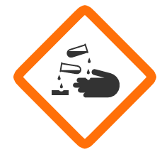 | Corrosive | - May cause burns to skin and damage to eyes. May also corrode metals.  - Avoid skin & eye contact,  - Do not breathe vapours.  - Avoid skin contact by wearing gloves, lab coats and aprons
 | Flammable | - Flammable when exposed to heat, fire or sparks, or give off flammable gases when reacting with water.  - Keep away from open flames
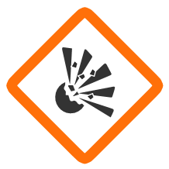 | Explosive | - May explode as a consequence of fire, heat, shock or friction.  - They can detonate at any time  - Chemicals with this label should be kept away from potential ignition sources.  - They should be handled with care and according to instructions.

 | Gas under pressure | - Container contains pressurised gas.  - This may be cold when released, and explosive when heated.  - These containers should not be heated.
 | Oxidizing | - Burns even in the absence of air, and can intensify fires in combustible materials.  - Should be kept away from ignition sources
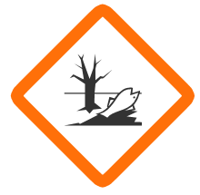 | Environme ntal | - Indicates substances that are toxic to aquatic organisms such as fish, or may cause long lasting environmental effects.  - They should be disposed of responsibly
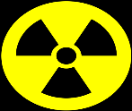 | Radioactive | - Wear protective clothing to avoid skin contact.  - Avoid long exposure  - Store in special containers or places.
 | Caution (Irritant) | - May irritate the skin, or exhibit minor toxicity.  - The chemical should be kept away from the skin and the eyes as a precaution.  - Avoid inhaling it more especially asthmatic

Consequences of accident in the laboratory
- It damages laboratory
- It spoils materials
- It causes injuries to student and the teacher
- Death

What should be done when an accidents happen in the laboratory?

- Apply first aid
- Take appropriate steps to control the accidents
- Report it immediately to the teacher

Applying safety measures in the laboratory for specific accidents
The following are some of the accidents and their emergency responses.
  - Fire outbreak
- Move to fire assembly points using fire exit points
- Inform the teacher or the instructor
- If you can, use the extinguishers to put off the fire
- If you can, switch off the main switch of thelaboratory wiring system
- Do not scream or run randomly.

  - Electric shock.
- Switch off the power at the socket first
- Pull out the victim from theappliances
- Give the victim first aid
- If not breathing, give him/her akiss of life
- Seek medical assistance from amedical personnel
  - Suffocation
- Take the victim out of the laboratory to open air for freshair
- Open all the windows and doors

  - Seek assistance from medical personnel

  - Chemical spillage on the skin, flow,table etc
- Pour a lot of pure water to the affected part to dilute the chemical
- In case the chemical is in contact with your eye, use the eye wash
- If you tasted the chemicals drink clean water
- Seek medication immediately.

  - Breaking of equipment
- Inform the teacher immediately
- With the help of the teacher,collect all pieces of broken apparatus and dispose them off properly

Exercise
- Explain why it is important to observe laboratory rules and regulations.
- State five laboratory safety rules and regulations.
- You are working in the laboratory and you see the hazard symbols shown in Figure below:

a | b

  - Describe the meaning of each symbol.

  - Describe the steps you would take to guard against the hazard depicted by each symbol
- Give three safety measures to be taken in case of fire outbreak.
CHAPTER 4: MEASUREMENTS

- The study of physics deals mostly with physical quantities.
- It involves investigation, making observations, collection of data and their analysis, interpretation and drawing conclusions.
- One important aspect in data collection is taking measurements.
- When taking measurements, one must first know the quantity to be measured and the unit for measuring it
- For purposes of uniformity, physical quantities have been assigned specific units which are acceptable world over.
Definitions Measurement
It is a process of assigning a number to a physical quantity such as length or mass. The process uses SI units.

Meaning of unit

A unit is a chosen standard size to which the measurements of a physical quantity is compared
Meaning of SI units
- SI Units is short form for System Internationale D’Unites (International system of units)
- SI units are international or universally accepted units in which physical quantities are measured
Types of physical quantities measured

- Basic or fundamental units

- Derived units

Basic or fundamental quantities
- These are quantities that cannot be obtained by any other quantity e.g. mass, time, length
- Other quantities are derived from basic
quantities
- These are measured using basic units
- There are 7 basic physical quantities tabulated below and their corresponding S.I units

Basic or fundament Quantity | SI Unit | Basic unit Symbol | Other common units
Length | Metre | M | cm, m, km
Mass | Kilogram | Kg | g
Time | Second | S | min, hr
Temperature | Kelvin | K | °C, °F
Light intensity | Candela | Cd
Electric current | Ampere | A
Amount of a substance | Mole | Mol

Derived physical quantities

  - Derived physical quantities are those which are obtained by combining two or more basic physical quantities
  - A derived physical quantity is one
which can be obtained by either multiplication or division of other basic physical quantities.
  - The table shows some of the derived physical quantities, how they are obtained and their SI Units:

Derived quantity | Symbol | Quantities derived from | Other units | SI unit
Area | A | Length × Length (L × L) | km2 | m2
Volume | V | L × W × H | m3 | L
Speed | V | 𝐷𝑖𝑠𝑡𝑎𝑛𝑐𝑒/𝑡𝑖𝑚𝑒 | km/h | m/s
Acceleration | A | 𝑆𝑝𝑒𝑒𝑑/𝑡𝑖𝑚𝑒 | m/s2 | m/s2
Force | F | Mass × acceleration | Kgm/s2 | Newton (N)
Pressure | P | Force/area | N/m2 | Pascal (pa), Atm, mmHg
Energy | E | Force × distance | Nm | Joule (J)
Density | P | 𝑀𝑎𝑠𝑠/𝑣𝑜𝑙𝑢𝑚𝑒 | 𝑘𝑔/𝑙 | Kg/m3

Important quantities
- Length
This is the distance between two fixed points
The S.I Unit is metre (M). The relationship between different units of length are listed in table below
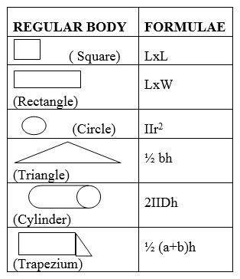
Area is converted from one level to another by division or multiplication by factor 100
Unit | Symbol | Comparison with m2
1 square kilometer  1 square metre  1 square centimetre  1 square millimetre | km2 m2  cm2 mm2 | 1 000 000 m2  1m2  0.000 1 m2  0.000 001 m2

- Length is converted from one level to another by division or multiplication by factor 10
Unit | symbol | Equivalence in metres
Kilometre | Km | 1000
Hectometre | Hm | 100
Decametre | Dm | 10
Decimetre | dm | 0.1
Centimetre | Cm | 0.01
Millimetre | Mm | 0.001
Micrometre | μ m | 0.000001

- Length is measured by a ruler and tape measure (for large objects) and Vernier calliper and screw gauge (for smaller objects)
- Area
Area refers to a measure of surface covered by a body.
It is measured in metre-square (m2), that means it is a derived quantity.
Other multiples and sub-multiples are; cm2, mm2, km2

Measurement of area for regular objects

- Volume
- Volume is the amount of space occupied by space
- The SI unit of volume is cubic metres [M3]. It is a derived quantity of length
- Multiples and submultiples are; mm3, cm3 and km3
- Area is converted from one level to another by division or multiplication by factor 1000

- Triangular prism ½bhl
Symbol | Relationship to m3
km3 | 1000 000 000 m3=1  km3
cm3 | 1m3= 1000 000 cm3
mm3 | 1m3=1000 000 000  mm3

- Sphere 4/3 πr3

The internal space occupied by an object or substance can be expressed in form of capacity. The SI unit for capacity is the litre (l). The table below shows some units of capacity.

Unit | Symbol | Relationship to litre
kilolitre | kl | 1000l =1 kl
centilitre | cl | 1l =100 cl
millilitre | ml | 1l =1000ml
Volume and capacity can be related asshown below;

1ml=1cm3 1000ml=1litre=1000cm3
1000 000 ml=1000litres=1000 000cm3=1m3

Measuring volume of a regular solids
A regular solid has a regular shape, such as a cube, a cuboid and a cylinder.
The volume of regularly shaped solids can be obtained by applying the appropriate formula i.e.
  - Cuboids L X W X H

  - Cylinder πr2h
Measuring volume of a regular solids
Instruments can also be used to measure the volume of liquids.
They include; Burette, Pipette, Measuring cylinder, graduated beaker and Volumetric flask:

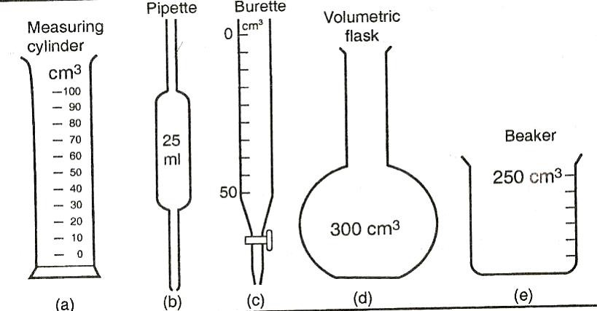

Measuring the volume of an irregular solid

AN IRREGULAR solid (e.g. a stone), does not have sides that can easily be measured.

Its volume can be found by a liquid and the measuring cylinder as follows;
- Pour water in the measuring cylinder and record its initial volume as V1.
- Drop in an irregular solid and record the new volume of water plus a stone as V2.
- Volume of an irregular solid=V2-V1

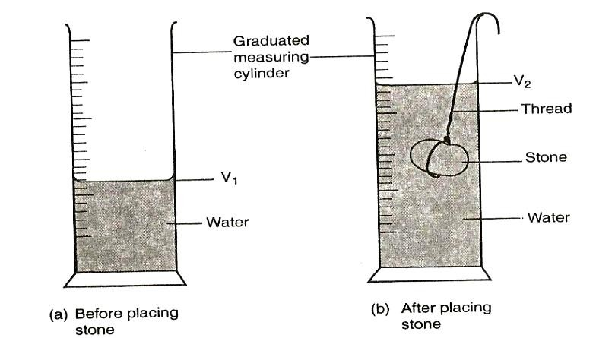

- Mass
Mass is the quantity of matter in a substance.
The SI unit is kg. The table below shows some units of mass
Unit | Symb ol | Explanation
Megatonne | M | 1000000000kg=1M
tonne | t | 1000kg=1 tonne
hectogram | hg | 1kg=10hg
gram | g | 1kg=1000g
centigram | cg | 1kg=100 000cg
milligram | mg | 1kg=1000 000mg

- Mass can be measured using electronic balance, beam balance and spring balance.

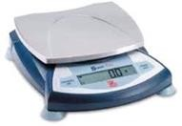 | 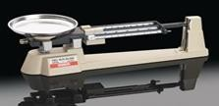
Top pan balance | Triple beam balance
- Time
It is a measure of duration of an event. The SI unit of time is seconds (s)

Time is measured using either a stopwatch (digital) or stop clock
Time | symbol | Equivalent in seconds
Microsecond | μ s | 0.000001
millisecond | ms | 0.001
Minute | min | 60
Hour | hr | 3600
Day | day | 86400
Week | wk | 604800

- Temperature
- Temperature is the degree of hotness or coldness
- The SI unit is Kelvin (K).
- In school laboratories, temperature is measured in 0C.
- To change oC to Kelvin, add 273 to 0C
K = oC + 273
Example
Convert 25oC in Kelvin T = (25 + 273)
= 298 K

- To change Kelvin to oC, subtract 273 from kelvin
oC = K - 273
Example
Convert 350 K to oC oC = K - 273

= 350- 273
= 77 oC
Temperature is measured by thermometer
There are several types of thermometers which include
- Liquid – in – glass thermometer. This is subdivided into
- Clinical thermometer: for measuring body temperature
- Six’s Maximum and Minimum
Thermometer
- Electrical resistance thermometer.
- Digital thermometer.
- Constant volume gas thermometer.
- Thermocouple thermometer.

- Density
The density of a substance is defined as
its mass per unit volume
Density = 𝒎𝒂𝒔𝒔
𝒗𝒐𝒍𝒖𝒎𝒆
The SI unit is kilogram per cubic metre (Kg/m3)
Conversion from kg/m3 to g/cm3
1g/cm3 = 1000kg/m3

Importance of units of measurements
- It makes the number meaningful
- It prevents accidents in some chemical
e.g. wrong dosage for sick people

Instruments of measurements
- Different quantities are measured by different instruments. The table below shows some quantities and their instruments of measurement.

Quantity | Measuring instrument | Units
Mass | Triple beam balance | Kg or g
Length | Meter rule,  Measuring tape, Vernier caliper, screw gauge | M, cm, cm, mm, nm
Volume | Measuring cylinder, Burette | 𝑚3 or 𝑙
Temperature | Thermometer | K, ℃ or ℉
Time | Watch | sec, min or hr

Prefixes of SI Units
In order to avoid writing very big or small values some prefixes are used in conjunction with the
S.I unit for are given dimension. Some of the prefixes used with S.I units of all
kinds are listed in the table below.

Prefix | Symbol | Magnitude |  | Normal value
Atto | Α | 10-18 |  | 1/1000 000 000 000 000 000
Femto | £ | 10-15 |  | 1/1000 000 000 000 000
Pico | Ƥ | 10-12 |  | 1/1000 000 000 000
Nano | Ղ | 10-9 |  | 1/1000 000 000
Micro | Ս | 10-6 |  | 1/1000 000
Mill | M | 10-3 |  | 1/1000
Centi | C | 10-2 |  | 1/100
Deci | D | 10-1 |  | 1/10
Deca | Da | 101 |  | 10
Hector | H | 102 |  | 100
Kilo | K | 103 |  | 1000
Mega | M | 106 |  | 1000 000
Giga | G | 109 |  | 1000 000 000
Tera | T | 1012 |  | 1000 000 000 000
Peta | P | 1015 |  | 1000 000 000 000 000
Exa | E | 1018 |  | 1000 000 000 000 000 000
Laboratory apparatus

These are tools used in the laboratory

Examples of laboratory apparatus and their uses
Measuring cylinder. Used for measuring volumes of liquids
Burette. For measuring accurate or exact small volumes of liquids during chemical reactions.
Volumetric flasks. For preparing accurate volumes of liquids.
Pipette: For transferring or measuring small exact quantities of liquids into the burette.
Beam balance. For measuring mass of a substance.

Funnel: Used to add liquids into flasks in small quantities.
Bunsen burner: Acts as a heat source for heating or boiling substances
Test tube: For heating or boiling substances
Stop watch. For measuring duration of time.
Beakers. For boiling and holding liquids.
Evaporating dishes. Used to evaporate water from solutions inorder to recover the dissolve solid.
Spatula. Used to take small quantities of solid chemicals from thecontainer.
Tongs. Used to hold hot crucible or

crucible cover.
Tripod stand. For supporting apparatus when boiling or heating liquids.
Clamp and clamp stand: Clamp Stand is used to mount apparatus. A clamp is used to hold apparatus.
Wire gauze. It is placed on the tripod stand to hold beakers whenboiling liquids.
Thermometer. For measuring temperature.
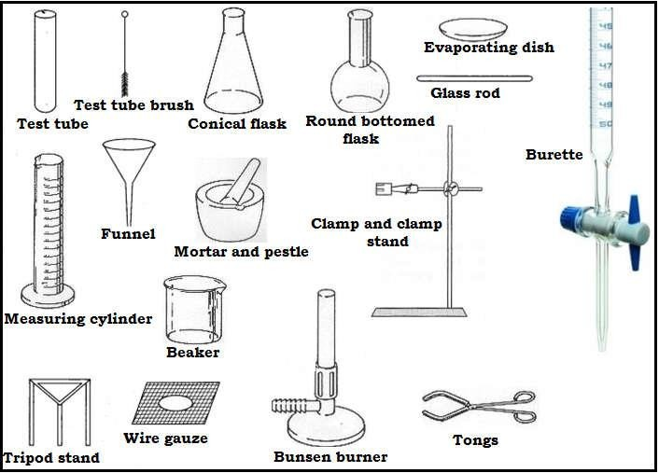

Protective equipment in the laboratory

In the chemistry, some of the protective equipment includes goggles, gloves, lab coats, respiratory/gas mask, eye wash station and fire extinguisher

Exercise
- Distinguish between a fundamental (base) quantity and a derived quantity. Give one example of each.
- Name three fundamental quantities and their SI units.
- Give a reason why it was necessary to
establish SI units
- Why is density a derived quantity?
- How many micrometres are there in 4 cm?
- Express the following in millimetres: (a) 2.7 m (b) 26.9 cm (c) 356 µm.

- What are the functions of the following laboratory apparatus
  - Burette b) test tube c) Bunsen burner
d) evaporating dish
- Describe how you would determine the volume of an irregular object such as a small stone

CHAPTER 5: PARTICULATE NATURE OF MATTER

Definition of matter

- Matter is anything that has mass and occupies space.
- Mass is the quantity of matter in a body
- Space occupied is the volume of a substance

- This definition shows that not everything is matter. Examples of non- matter things are shadow and vacuum.

- The shadow and vacuum do not have mass and do not occupy any space.

- Matter is made from particles. These particles are tiny that they cannot be seen with the naked eye.

- Different substances are made from different particles and

these particles have different sizes.

- The particles are atoms and molecules.

EVIDENCE OF EXISTENCE OF MOLECULES IN A SUBSTANCE

Experiment one: To Demonstrate existence of molecules in a substance Apparatus: Beaker and potassium permanganate crystals

Procedure
- Pour water into the beaker to half full.
- Dissolve the potassium permanganate crystals until the solution is purple.
- Transfer half of the solution to another beaker and add water
- Continue the process with other beakers, comparing the colour to each other.
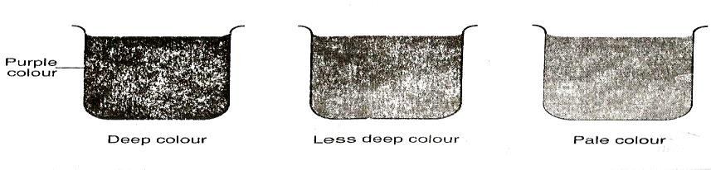
Observation
- The process of dilution can continue until the solution appears colourless. This suggests that the particles of potassium permanganate are spread evenly on water.
- As water particles increase, the particles of potassium permanganate are spread further, making the purple colourless and less until it appears colourless

Conclusion
Potassium permanganate is made up of tiny particles.
Experiment two: If a bottle of perfume is opened in one corner of the room, perfume forms gas which is able to move freely in the air. This enters your nose for you to start smelling perfume.

This proves that a substance like perfume contains particles that we cannot see with our eyes. These particles are called molecules.

THE KINETIC THEORY OF MATTER
- The word kinetic is derived from the Greek word “kineo” which means “I move”.
- The kinetic theory explains how matter behaves.
- Kinetic theory of matter states that matter is made up of tiny discrete individual particles that are continuously in random motion

Three main points can be obtained from the kinetic theory
- All matter is made up of tiny, moving particles, small enough to be seen by our naked eyes.
- The particles move all the time. And the speed of the particles is affected by temperature. i.e. the higher the temperature the faster is their speed.
- The heavier particles move more slowly than lighter ones.

States of matter
- The theory explains how particles are packed in solids, liquids or gasses; the attractive forces between them; and the effect of temperature on them.
- The arrangement of particles of matter

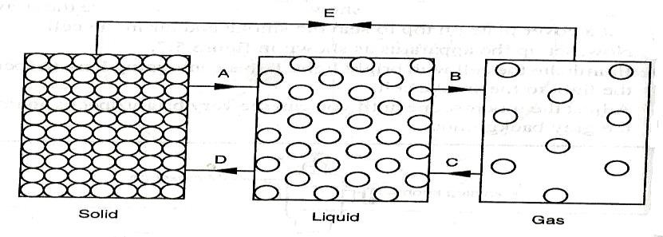
and the way they move determines the state of a substance, i.e. whether to be in solid, liquid or gaseous state.
- Therefore, the three main states of matter are
- Solids
- Liquids
- Gases

A substance can exist as a gas, liquid and a solid. For example, water is a solid in the form of ice, a liquid a gas in form of vapour.

Arrangement of particles in the three states of matter

In solids

Particles are held together by strong forces in a three dimensional structure. The particles are closely packed. And they do not change position but vibrate to and fro about one position.

In liquids

Particles are held together by weaker forces than in solids. The particles can change position by sliding over each other.

In gases

Particles are held together by very weak or small forces of attraction. The particles can move away from each other
and travel in all directions.

Properties of a solid

- It is hard.
- It has a fixed or definite shape.
- It has a fixed or definite volume.
- It cannot be compressed.
- It vibrates about a fixed mean position.

Properties of liquid
- It pours easily because particles slide over each other.
- It has a fixed or definite volume.
- It has no fixed shape (it takes the shape of the container)
- It is difficult to compress a liquid.
- The vibration of particles is greater than in solids.

Properties of a gas

- It is lighter
- It has no fixed shape; it takes the shape of the container.
- It has no fixed volume; it takes the volume of the container.
- It can easily be compressed.
- Vibration is much greater in a gas because particles have enough space to move.

Motion of particles
- When a particle is moving, it collides with other particles. After the collision it moves in different direction and with a different speed.
- Hence particles move at different speed and in different directions. This movement of particles in gases is called random motion.

- The speed of the particles of gas increases with an increase in temperature because particles gain kinetic energy. Kinetic energy is the energy of movement.

Diffusion of particles in three states of matter
- Diffusion is a process by which particles spread from regions of high concentration to those of low concentration.
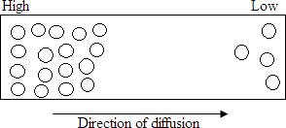
- Diffusion takes place in solids, liquids and gases.
- In solids, diffusion is exceedingly slow but occurs when two metals are placed in contact with each other
- Diffusion in liquids occurs at a faster rate than in solids.
- Diffusion in gases is faster due to their low density, high kinetic energy and weak cohesive forces
- Diffusion does not stop taking place until there is equal distribution of particles.
- For example, if a bottle of perfume is opened in one corner of a room, the scent can very soon be detected throughout the whole room because there is high concentration of perfume molecules where the bottle is.

Rate of diffusion in gases

- Different gases have different rates of diffusion depending on their density or
relative masses.
- A gas of high density has heavier particles hence moves more slowly than lighter one.
- Different gases have different rates of diffusion

Example
- In the figure below, ammonia gas and hydrochloric acid gas diffuse and react.
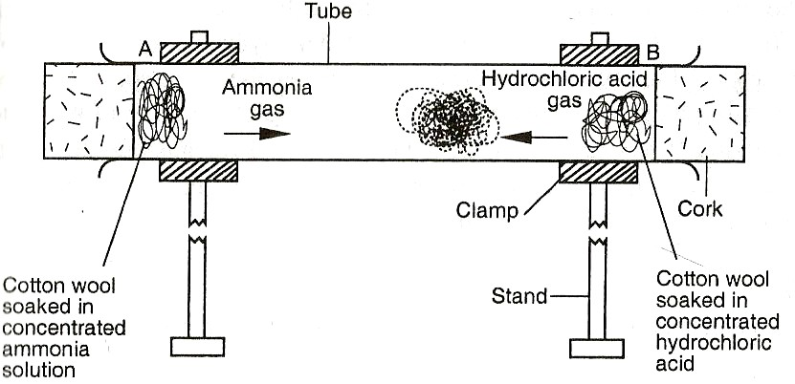
- A white deposit of ammonium chloride forms on the walls of the glass tube in the region nearer end B.
- This suggests that ammonia gas diffused at a higher rate than hydrochloric acid gas. This also means ammonia gas has lighter particles compared to hydrochloric acid

Factors affecting diffusion
  - Size of particles: Smaller particles diffuse faster than larger particles
  - Diffusion gradient: This is the difference in concentration between two regions. Particles move from high to lower concentration region. Diffusion is faster when the gradient is big
  - Temperature: Temperature increases the kinetic energy of particles hence

faster diffusion

  - Density: Diffusion in gases is faster due to their low density than in other states of matter
  - Surface area: Larger surface area provides more space for diffusion

CHAPTER 6: CHANGES OF STATES OF MATTER

Introduction
- A substance that is in solid or in liquid state can change from one state to the other once heat or temperature and pressure are changed.
- Change of state of matter is a physical change in matter
Temperature

Temperature refers to the degree of hotness or coldness. Temperature measured in Kelvin (K) or degrees Celsius (℃ )

Heat

- Heat refers to a form of energy that passes from a body of high temperature to a body of low temperature. Heat is measured in joules

- When heat is supplied or removed several changes take place in matter. Some of them are:
- Kinetic of particles change in any state of matter.
- State of matter changes
- Volume of substance changes
- Density changes.
- Force between particles changes.
- State of matter changes.

Processes of change of state of matter

    - Melting. Change of state of matter from solid to liquid. The temperature atwhich matter changes from solid to liquid is called melting point.

- When a substance is changing its state from solid to liquid, heat is required.

- Thermal energy absorbed during the melting process is called latent heat.

- The term “latent” means “hidden” and no change in temperature occurs until all the ice has melted.

Uses of melting
- It is used in welding
- It is used in cutting and shaping of metals in the industry

    - Evaporation. Change of state of matter from liquid to gas. The temperature at which matter changes from liquid to gas is calledevaporation point. It is equal to the boiling point. Heat is also required for evaporation to take place
Uses of evaporation
- It is used in drying clothes
- It is used in obtaining crystals from solutions

Note: Both melting and evaporation requires heating which raises temperature

SECTIONS OF HEATING GRAPH

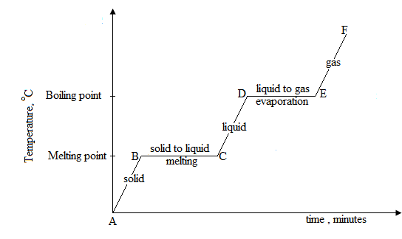
Section AB: The substance remains in solid state. The heat energy provided is absorbed by the solid particles and they vibrate harder about their fixed positions.

Section BC: A mixture of solid and liquid will be observed at this temperature which is called the melting point of the substance. At point C, the solid has turn completely into a liquid.

Section CD: The substance remains in liquid state. The liquid particles continue to absorb heat energy and their kinetic energy increases, causing the temperature of the liquid to rise.

Section DE: A mixture of liquid and gas will be observed at this temperature which is called boiling point of the substance. At point E, the liquid has turn completely into a gas.

Section EF: The gas particles will absorb energy and move further apart as they
become more energetic. The temperature of the gas will rise.

Summary

Slope sections of the heating curve: As a substance is heated, it absorbs heat energy and its temperature rises, then it changes from solid to liquid and finally to gas.

Flat sections of the heating curve: The flat section shows the melting point and boiling point. Here the temperature remains constant over a period of time as energy being absorbed is used to change the state of a substance

- Freezing. Change of state of matter from liquid to solid. The temperature at which matter changes from liquid to solid is called freezingpoint.
- Condensation. Change of state of matter from gas to liquid. The

temperature at which matter changes from gas to liquid called is condensation point

SECTIONS OF COOLING GRAPH/ CURVE

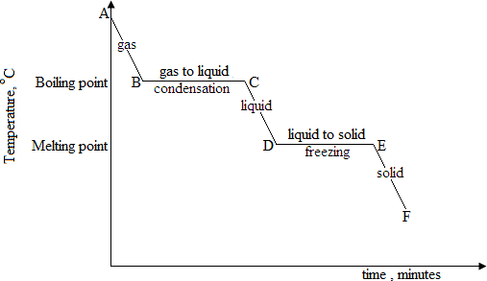

Section CD: The substance remains a liquid. As cooling takes place, the particles lose kineticenergy and moves more slowly.

Section DE: A mixture of a liquid and solid is observed as the liquid particles rearrangethemselves to form a solid structure.

Section EF: The temperature of the solid drops as cooling continues.

Summary

Slope sections of the cooling curve: As a substance is cooled, it loses heat energy and itstemperature falls, then it changes from gas to liquid and finally to solid.
Flat sections of the cooling curve: The flat section shows the melting point and boiling point. Here the temperature remains constant over a period of time as energy being lost is used to changethe state of a substance.

- Sublimation. Change of state of matter direct from solid to gas. The temperature at which matter changes from solid to gas is called sublimation point. Substances which can sublime include:
- Iodine
- Ammonium sulphate
- Ammonium chloride
- Carbon dioxide (upon cooling to form ice)

- Deposition. Change of state of matter direct from gas to solid. The temperature at which matter changes from gas to solid is called deposition point.
Solution
Distance above the sea-level=450m Every 300m, temperature change= 10C

At 450m, temperature change
450𝑚

Summary of change of states of
=
300𝑚
x 10C

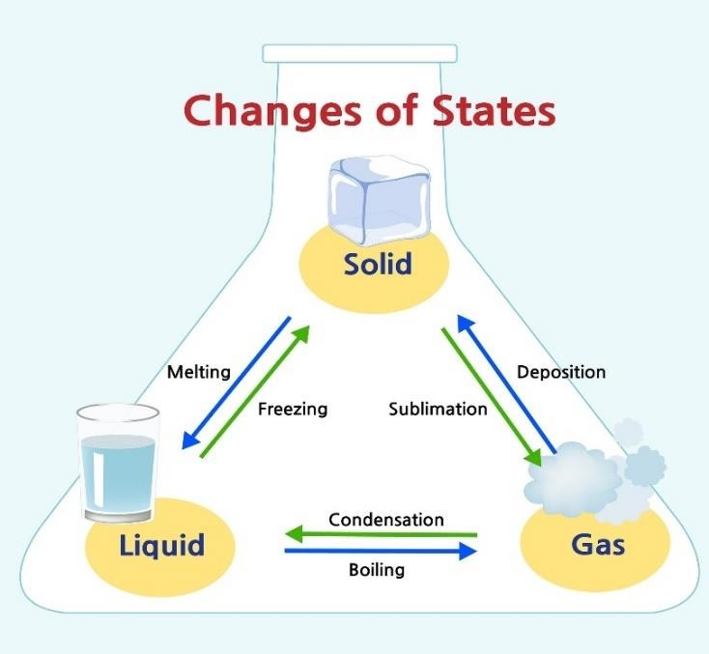
matter

Factors affecting boiling point of a liquid.

- Pressure. At standard atmospheric pressure (760 mmHg), pure water boils at 100℃
- Altitude. This is the height above sea level. As the height above sea level increases, the boiling point decreases due to low atmospheric pressure. The boiling point of water changes by 10C for every 300 m increase in depth, up or down the sea level.

Example

Mchinji hill is 450m above the sea-level; calculate the boiling point of water at the top of Mchinji hill.
= 𝟏. 𝟓℃

Boiling point for water at sea level= 𝟏𝟎𝟎℃ Therefore, the boiling point of water at Mchinji hill is 𝟏𝟎𝟎℃ − 𝟏. 𝟓℃ = 𝟗𝟖. 𝟓℃

- Impurities. These are extra substances added to a pure substance. They lower the boiling point and increases the melting point of the substance.

Factors affecting the rate of evaporation.
- Temperature. Increase in temperature increases the rate of evaporation. Molecules gain more kinetic energy.
- Surface area. Evaporation takes place on the surface of theliquid. Increase in surface area increases evaporation rate.
- Pressure. Decrease in pressure on the surface of liquidincreases the rate of evaporation of a substance.
- Air current. Air current moving on the surface of the liquid increases the rate of evaporation.
- Nature of liquid. Boiling of the substance depends on thenature of the liquid. The liquid that has low boiling point evaporates fast than that with high boiling point.

Similarities between boiling and evaporation
- In both processes liquid changes its state to vapour.
- In both latent heat of vaporization is required.

Differences between boiling and evaporation
- Evaporation takes place at all temperatures while boiling takesplace at fixed temperature called boiling point.
- Evaporation takes place at the surface of the liquid while boilingtakes place throughout the mass of the liquid.
- Once evaporation takes place, there is a fall in temperature whichcauses a cooling effect while once boiling takes place, the temperature of the liquid remains at constant.
- Evaporation brings about cooling effect while boiling does not bring about cooling effect.
- Evaporation is a slow and a calm process while boiling is a rapidand a noisy process.

CHAPTER 7: FORCE

Definition of force
- It is a pull or a push on an object
- The SI unit of force is the newton (N), named after the famous physicist Sir Isaac Newton (1642 –1727).
- It is measured by a spring balance.

Representing forces
- Force is a vector quantity. It has both magnitude(size) and direction
- The magnitude is represented by a
straight line while the direction is shown using an arrow. The arrow points towards the direction of force as shown in Figure below
F

Effects of force
- It changes state of the body by causing the body to start or stop moving.
- It changes the shape of the body like deforming the body
- It can cause heating effect due to friction
- It can cause noise pollution due to friction
- It can cause the object to wear or tear
Resultant force
It is the final force acting on an object.
Resultant force is found by
- Subtraction if two or more forces act in opposite directions
- Addition if two or more forces act in the same direction
Balanced forces
- Forces are said to be balanced when they have the same magnitude (size) and act in opposite direction. This means they act away or towards each other
- Any time there is a balanced force on an object; the object stays still or continues to move at the same speed and in the same direction.
- The resultant force is 0

Example: Figure below shows balanced forces acting on a stationary box.

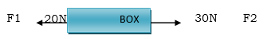
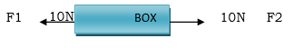
Resultant (Final) force=F2-F1

=10N-10N

= 0N

Unbalanced forces
- Forces are said to be unbalanced when they have the different magnitude (size) and act in opposite direction
- These forces do not cancel out each other. When unbalanced forces act on an object, the object moves towards where greater force is going.
- The resultant force is greater than 0

Example: Figure below shows unbalanced forces acting on a stationary box.

The final force acting on an object is found as:

Resultant (final) force=F2-F1

=30N-20N =10N

Direction of the final force: towards F2
Types of forces
Some types of forces are listed below
- Gravitational force: A force which pulls the body towards the centre of the earth. It is a force that causes objects to fall down to or stand on Earth
- Tension Force: Tension force is a force created when two opposing forces are applied. The pull of a string or spring at both of its ends is called Tension
- Compressional force: It is a force whch causes when two objects converge/meet
- Upthrust Force: The upward force acting on an object immersed in a fluid (liquid or gas). It is found by:
Upthrust force = weight of object in air –
weight of object in the liquid
Note: An object in a vacuum will not experience upthrust.
Example
An object weighs 80N in air and 60N when immersed in water. Calculate force acting on the object.
Solution
Upthrust force = weight of object in air –
weight of object in the liquid
=80-60 20N
- Magnetic force: Magnetic force is the force of attraction or repulsion between a magnetic material and a magnet

- Electrostatic force: This is a type of force which causes attraction or repulsion between charges. Charges can be positive or negative.

- Electric force: It is a force which acts on two conductors carrying electricity

- Action and reaction force: They are two equal forces but acting in opposite

to each other.

- Surface tension: This is a force that causes the surface of a liquid to behave like a stretched plastic skin.
- Cohesive force: The force of attraction between molecules of the same kind is known as cohesive force
e.g. A water molecule and another water molecule.

- Adhesive force: The attraction between molecules of different kinds is known as adhesive force e.g. between water molecules and molecules of the container in which the liquid is put

- Frictional force: This is force that opposes motion of a moving object.
Advantages of frictional force
- It can provide grip on the ground like tyres of cars.
- For braking. Cars use pads made from material that offer a lot of friction.
- Conveyer belt in factories do not slip because of friction.
- Nails are able to hold pieces of wood tightly together because offriction.
- Nuts, bolts, screws jacks make use of friction to work
- It is used in sea saw because it has turning effect
- It useful in lighting a matchstick

Disadvantages of frictional force
- A lot of energy is wasted due to friction
- Cause tearing and wearing out of bodies.
- It slows down motion of a moving object
- It causes noise pollution when rough
surfaces are rubbed together.

Factors affecting friction force

- The nature of the surface where the object is sliding.
Frictional force is bigger on rough surfaces than on smooth surfaces.
- The size of the sliding object.
The frictional force is greater when the object is bigger than when it is small.
- Angle at which the bodies in contact

Ways of reducing friction
- Polishing surfaces
- Lubricating parts
- Rolling instead of sliding

Finding the size of the frictional force

When pushing an object, for instance a box, the ground surface provides a frictional force equivalent to the size or weight of the object.
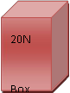

For a box to be pushed forward one should first provide a force of 20N which is equivalent to the frictional force, then he must exert an extra force, that the pushing force is greater than the frictional force.

Pushing force= frictional force + extra force.

𝐹 = 𝐹𝑟 + 𝑓

Mass and weight

Mass is the quantity of matter in an object while weight is a measure of the pull of gravity on an object.

The S.I unit of mass is kg (kilogram) and of weight is Newton (N).

Differences between mass and Weight

Mass | Weight
It is a quantity of matter on a body. | It is a pull of gravity on a body
It is measured in kg. | It is measured in (N)
Same everywhere | Varies from one place to another.
Measured using a beam balance. | Measured using a spring balance
Has magnitude only (scalar quantity) | Has both magnitude and direction. (vector quantity)

Note: Weight on moon= 1/6th weight on Earth

Relationship between mass and weight

Weight =Mass x acceleration due to due gravity (g)

W=mg

The acceleration due to due gravity (g) is 10N/Kg

Example
A body has a mass of 300kg on earth.
Find:
- Its mass on earth
- Its mass on the moon
- Its weight on the moon

Solution

- Weight= mg
W= 300kg x 10N/Kg
W= 3000 N
- Since mass does not change regardless of place, its mass remains 300kg
- W=1/6 weight on the earth soW= 1/6 x 3000N
W=500N

Exercise
  - Define force and state its SI unit
  - Why do objects fall back to Earth when thrown into air?
  - How is force represented on a piece of paper?
  - Name the instrument which is used to measure
    - weight b) mass
  - A first aid kit box used at a fire accident scene has a weight of 2 500 N.
    - What is its mass?
    - How much would it weigh on the surface of the moon
  - Calculate the weight of the following. (Take g = 10N/kg.)
- 300 g mass of water
- 700 kg mass of sand
  - A metal of mass 2.5kg in air weighs 2.3kg when immersed in water. Find the

upthrust force acting on the metal (Take g
= 10N/kg.)
  - State any two differences between mass and weight

CHAPTER 8: WORK
Definition of work
- Work is defined as the product of force and distance moved in the direction of the force. i.e
- Work = force × distance moved in the direction of the force

W = F × d
- Force is measured in newton while distance is measured in metres. Therefore, work is measured in newton metre.
- The SI unit of work is joule.
- Where 1 joule =1 newton × 1 metre
- A joule is the work done when a force of 1 newton moves a body through a distance of 1 metre.
- Bigger units used are kilojoules (1 kJ)
= 1 000 J
- Megajoule (1 MJ) = 1 000 000 J
•
- Note: Whenever work is done, energy is transferred.

Examples
- James lifts a mass of 3kg vertically through a distance of 2m.Calculate how much work is done
Solution
𝑊 = 𝐹 𝑥 𝑑 = 3𝑘𝑔 𝑥 10𝑁/𝑘𝑔 𝑥 2𝑚

𝑊 = 60𝑁𝑀 = 60𝐽
- A builder climbs a staircase of height 4m. Find the work done by thebuilder in raising herself through this height, if her mass is 60kg.

Solution
𝑊 = 𝑓 𝑥 ℎ = 𝑚𝑔 𝑥 ℎ
W= 60𝑘𝑔 𝑥 10𝑁/𝑘𝑔 𝑥 4𝑚
𝑊 = 600 𝑥 4
𝑊 = 2400𝐽

Exercise
- Explain why in trying to push a rigid wall, a person is said to be doing no work.
- Define the term work and state its SI unit.
- How much work is required to lift a 2 kilogram mass to a height of 10 metres (Take g=10 m/s2).
- A garden tractor drags a plow with a force 500 N a distance of 2 metres in 20 seconds. How much work is done?

CHAPTER 9: ENERGY

Definition of energy.

Energy is the ability or capacity to do work. It is measured in joules (J).
Sources of energy
Some sources are renewable while other sources are non-renewable.

Renewable sources
These are energy sources that do not get used up. They are continuously replaced by natural processes and are clean with little or no pollution to the environment.

Solar energy. Energy from the sun. It is used by both plants and animals. It comprises light and heat. Light energy can be trapped in solar cells and stored in accumulators as electrical energy.

Geothermal energy. It is the higher temperature found in someregions of the earth. Water trapped between rocks is heated and may be released to the earth. This vapour can be used in generating electricity. This type of electricity is called geothermal electricity.

Biomass and bio gas energy. It is obtained from degradation oforganic materials such as animal and agriculture wastes. Biogas may be trapped using a biogas plant.

Wind energy. A number of machines can be driven by wind.Examples include wind mills and water pumps

Non-renewable sources
These are energy sources that use stored chemical energy and get used up. They cannot be renewed naturally and cause pollution to the environment hence considered unclean.

Fossil energy. Energy trapped by the plants from the sunlight during photosynthesis long ago. During decaying, the plants areconverted to coal, oil or natural gases. These are extracted for human use. E.g. fuel for motor vehicles.

Nuclear energy. Nuclear reactors are
used to produce this energy.

Forms of energy

Energy is not visible, it occupies no space and has no space and has neither mass nor any other physical property that can describe it.
However, it exists in many forms. These forms are: mechanical, chemical, thermal, sound, light, electrical and nuclear.
  - Mechanical energy.
Mechanical energy is the energy possessed by a body due to its motion or due to its position.

It is divided into three; potential, kinetic energy and elastic energy of aspring

- Gravitational Potential energy

It is the energy that a body possesses due to its position. The bodies that fall down have stored energy called gravitational potential energy.

Potential energy = work done
𝒘𝒐𝒓𝒌 𝒅𝒐𝒏𝒆 = 𝒇𝒐𝒓𝒄𝒆 × 𝒅𝒊𝒔𝒕𝒂𝒏𝒄𝒆
= 𝒘𝒆𝒊𝒈𝒉𝒕 × 𝒉𝒆𝒊𝒈𝒉𝒕

= 𝒎𝒈𝒉
Therefore, potential energy

𝑷. 𝑬 = 𝒎𝒈𝒉

- Elastic potential energy

This is the energy due to the state of strain of an object. Compressed or stretched spring goes back to its original shape when released. The work done on

stretching or compressing the spring is called elastic potential (strain) energy. The elastic potential energy associated with the spring force, PEs, by;
PE 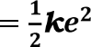

Where k is spring constant (always given), e is the extension of the spring.

- Kinetic energy (KE)

Kinetic energy is the energy possessed by a body due toits motion. KE occurs When a resultant or unbalanced force acts on a moving particle (body), the particle accelerates in the direction of that force. The work done on the body results in increased motion energy.This motion energy is called kinetic energy (K.E).
The kinetic energy of a moving body is given by:

where m and v are the mass and velocity of the body respectively

Examples of objects that possess KE include moving air, rotating windmills, falling water, rotating turbines and a moving stone
  - Chemical energy
- This is a form of stored energy that is released when needed, by the conversion process called a chemical reaction.
- Chemical energy is therefore a form of potential energy. Food is a source of chemical energy and batteries store chemical energy.

  - Thermal energy
- This is the energy due to difference in
temperature i.e. heat energy. Heat flow from region of higher temperature to a region of lower temperature.

  - Sound energy

This is the energy due to mechanical vibrations such as ringing bells, hitting drums and other musical instruments andso on.

  - Electrical energy
Electrons are made to go around and electrical circuit byproviding them with energy from a batteryor a generator. As they move round a circuit they carry electrical energy from onepoint to another. This energy due to the flow of charges is called electrical.
  - Nuclear energy.
It is the energy stored in the nuclei of an atom. Energy is released in two ways:

- When a heavy nucleus is split into lighter nuclei. This is called nuclear fission
- When smaller nuclei combine toform larger one. This is called nuclear fussion.
  - Light energy
This is the energy that enables us to see. It comes from luminous sources such as sun, electric bulbs, wood fire,fire flies, candles etc.
Energy transformation Transducers
In most energy transfer processes, the
initial amount of energy is changed to other forms of energy. For example, swinging a simple pendulum like in the diagram below:

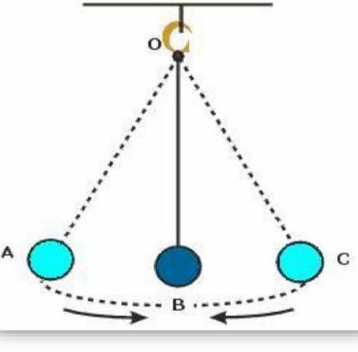
The pendulum at point A and C only possesses Potential Energy (P.E). At point B, it possesses Kinetic Energy (K.E).
Definition: A transducer is a device that converts energy from one form to another
Examples of transducers
- Thermocouple. Converts heat energy to electrical energy
- Dynamo. Converts kinetic energy to electrical energy
- Electric motor. Converts electric energy to kinetic energy
- Electric iron. Converts electrical energy to heat energy
- Bulb. Converts electrical energy to light energy
- Microphone changes electric energy to sound energy
- Wind turbines use wind energy to transform it into electricity

Law of conservation of energy

- It states that energy can neither be created nor destroyed but can be converted from one form to another.
- This simply means transducers do not lose or destroy energy, rather simply convert it from one form to another
- Energy can be inter-converted among
many forms, mechanical, chemical, nuclear, electric, and others but the total amount of it remains constant
Example one

A boy climbs a ladder with a force of 50N through a distance of 3.5m.
- Calculate work done
- State the energy changes that take place

Solution

a. 𝑊 = 𝑓𝑑
𝑊 = 50𝑁 𝑥 3.5𝑚
𝑊 = 175𝐽

b. Chemical energy of the muscles changes to kinetic energy(movement) then to potential energy (due to height).

Example two
A crane is used to lift a body of mass 30kg through a vertical distanceof 6.0m.

- How much work is done on the body?
- What is the P.E gained by body at this height?

Solution

  - W = f x d

𝑊 = 𝑚𝑔 𝑥 𝑑 W = 30 x 10x6
𝑊 = 1800𝐽

  - Work done = Potential energy Therefore, potential gain is 1800J

Exercise
- Table below shows how energy is converted from form A to form B and

the devices concerned. Complete the table
Form A | Form B | Device
Electrical | Sound | Loudspeakers
Electrical | Kinetic
 | Electrical | Battery
Sound | Electrical
 | Electrical | Thermocouple
 |  | Heater

- Define the term energy.
- State and explain briefly six forms of energy.
- Differentiate between:
  - Potential energy and kinetic energy.
  - Gravitational potential energy and elastic potential energy.
- A brick of mass 0.5 kg is lifted through a distance of 100 m to the top of a building. Calculate the potentials energy attained by the brick
- What are the advantages of using renewable sources of energy over non- renewable sources

CHAPTER 10: ELECTRIC CURRENT

A solid material contains the following particles in their atom:

- Protons: these are positively charged particles (+). They are usually denoted p
- Neutrons: these particles have no charge (0). They are usually denoted n
- Electrons: these are negatively chargedparticles (-). They are usually denoted e
In solid material electrons (negative charges) are the ones that are free to flow or move.

A solid material in which electrons are free tomove easily is called a conductor. A solid material in which electrons are not free tomove easily is called a non- conductor.

The flow of electrons in the conductor and inthe circuit is called Electric current. The symbol for current is I.

Definition of Electric current
- Electric current is the rate of flow of charges (electrons) through a conductor
- The charges (electrons) flows from the negative side of an electric field to the positive side.

I =Q/t i.e. Electrical current (I)
=quantity of charge (Q)/Time (t)

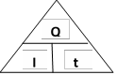
Charge (Q) is measured in units called coulomb (C)

A coulomb is the quantity of electricity which passes a given point in circuit in 1 second when a steady current of 1 ampere flows

Example
An electric charge of 50 C flows past a point in a wire in 5 seconds. Calculate the current flowing in the wire.

Solution
I =Q/t

I= 50C/5s = 10 A

Direction of flow of electric current
If a cell or a battery is connected across the conductor, the electrons (negative charges) will flow from the negative terminal to the positive terminal. This is simply the direction of electrons.
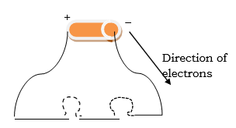
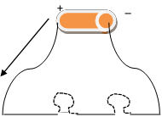
The above diagram shows the direction of electrons

The above diagram shows the direction of current.

When dealing with electricity we consider that current flows from positive terminal to negative terminal.

This type of current is called
conventional current. Simple electric circuit
Circuit is a complete path along which the charges will flow.
Electric circuit is a complete path along which negative charges or electrons flow.

Drawing an electric circuit
An electric circuit can be drawn by using the symbols of electrical apparatus.

Below are some of electrical symbols.
+ –

Name of component | Symbol | Definition
Cell |  | Small source of electric energy.
Battery |  | Large source of electric energy.
Power supply |  | D.C mains.
Open switch |  | Breaks the circuit. No current flows
Closed switch |  | Completes the circuits. Current flows
Wires joined |  | Junctions
Connecting wires |  | Wires that joins two or more components in an electric circuit.

Lamp/bulb |  | Convert electric energy to heat and light.
Ammeter | 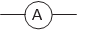 | Measures electric current.
Voltmeter | 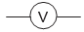 | Measures p.d and voltage.

Below is an example of a circuit diagram. A simple electric circuit can be composed of a connecting wire, a cell, a switch and a bulb
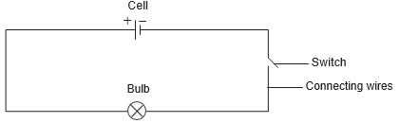

Measuring current

In the circuit where a bulb is used, the flow of current is noticed by the bulb lighting up. In most cases, the brightness of the bulb is used to show the amount of current which is flowing.
When the bulb is dim, it means there is low current while when the bulb is brighter, it means there is high current.

The brightness of the bulb can be increased by increasing the number of cells in the circuit.

The following can be deduced
- If there is high current, it means the electrons are travelling very fast in the circuit. The bulb is brighter
- If there is low current, it meansthe electrons are travelling at a low
speed. The bulb is dimmer

Although the brightness of the bulb will determine if there is high current or low current in the circuit, this does not provide a numerical value.

Therefore, there is an instrument used to measure electric current. This is called Ammeter. It measures electric current in Amperes (Amps).

Below is a symbol for ammeter

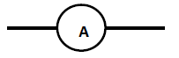

Connecting an ammeter in the circuit

When connecting an ammeter in the circuit, the following must be observed:

- Connect the positive side of an ammeter to the positive side of the cell or power supply. And negative side of ammeter to the negative terminal of the cell or power supply.
- Connect the ammeter in line with a component. This is so because an ammeter has a very low resistance. It effects on the flow of current is negligible. It

just acts like any wire in the circuit

Types of circuits

There are two types of circuits namely; series and parallel.
  - Series circuit
A series circuit is the type of circuit in which components are connected in a straight line. It has one conducting path only.
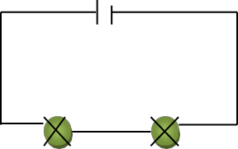
Flow of current in a series circuit
- In this circuit components are connected one after the other. All the current coming from the cell or battery or power supply goes through all the components.
- Therefore, current in series circuit is the same across each and every component.
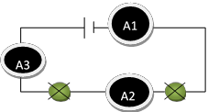
Figure above shows ammeters A1, A2 and A3 measuring current in a series circuit. Therefore, A1=A2=A3

Advantages of a series circuit

- It uses less electricity than if thebulbs are connected in parallel.
- You can add more power sources e.g.
cells.

Disadvantages of a series circuit
- If one bulb blows the circuit is broken and no current flows.
- If more bulbs are added, the brightness of the bulbs would dim.
- It is not possible to control the lights in different rooms throughout the house on the same circuit. Therefore, it is not practically used for lighting in the house.
  - Parallel circuit
A parallel circuit is the type of circuit to which components are connected in branches. It has more than one conducting path.
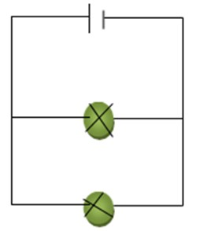

Flow of Current in parallel circuit

- The current coming from the power source splits up and goes through each branch.
- Therefore, in parallel circuit, the sum of the current in branches equals current from or towards the power supply. See the diagram below.

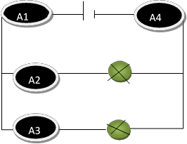
In the figure above; A1=A2+A3

And A4=A2+A3.

Therefore A1=A4

Advantages of a parallel circuit
- If one bulb blows there will still be a complete circuit through the other bulbsso it will remain lit.
- The brightness of the bulbs would be greater than the brightness of bulbs in series.

Disadvantage of a parallel circuit
It uses more electricity than if connected in series.

CHAPTER 11: VOLTAGE
- In conductors, electrons are able to flow freely. This flow of electrons is at random (flow in all directions). Therefore, there is no defined direction of electrons.
- If a cell is connected across a conductor, electrons now flow in the direction away from negative terminal and towards a positive terminal. The net flow of electrons is possible due to an electrical push provided by a cell or a battery. This electrical push is called voltage.
- Voltage is the electrical push provided onelectrons in the circuit or
conductor.
- Voltage in a circuit is provided by a cell or battery or generator or dynamo.

Measuring voltage

Voltage is measured in volts (V) by an instrument called voltmeter. Below is a symbol for voltmeter
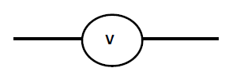
Connecting a voltmeter

- A voltmeter can be connected in a parallel circuit by considering that voltage is dropped across a component which has resistance. Hence, voltmeter must be connected across a component.
- A voltmeter is connected in parallel circuit because it has very high resistance, and its effect on the flow of current can be so great if it is connected in a series circuit.
- The positive side of the voltmeter must be connected to the positiveside of the supply or cell and viceversa.
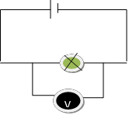
Figure above shows how to connect a voltmeter.

Voltage in series andparallel circuits
- In series circuit, current increases with an increase in the number of

Voltage in series circuit
cells. The brightness of the bulb

In a series circuit, the sum of the voltages across the components equals the voltagefrom the supply.
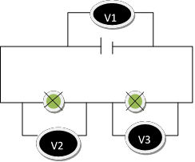
In the diagram above; V1=V2+V3

VOLTAGE IN A PARALLEL CIRCUIT

In a parallel circuit, the voltage across the components in branches is the same and equal to the voltage across the supply.
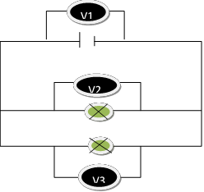
In the figure above; V1=V2=V3

Effects of increasing the number of cells and bulbs in series and parallel circuit
Series circuit
  - cells
increases with an increase in number of cells.
- As the number of cells increases, the electrical push on electrons also increases, hence the fast flowof electrons and the high current in the series circuit.
  - Bulbs
- The brightness of the bulbs decreases with an increase in the number of bulbs in series circuit because all the bulbs are sharing the voltage from the same cell. This reduces the voltage across each bulb and reduces current and brightness.

Parallel circuit
- Cells
- Increasing the number of cells in a parallel circuit has no effect on the brightness of the bulb.
- Bulbs
- The brightness of the bulbs is not affected by increasing the number of bulbs in a parallel circuit. This is so because each bulb is connected directly to the cell. Therefore, each bulb uses the same voltage and the same current.

CHAPTER 12: ELECTRICAL RESISTANCE

- Electrical resistance is the opposition to theflow of electrons in the circuit.
- If the resistance in the circuit is high, electrons travel slowly and produce

less current and vice versa.

- Different materials have different resistance. For instance, copper wire has low electrical resistance hence high conductivity. Nichrome wire has high resistance hence low conductivity.
Finding the resistance of a material
We can find the resistance of a wire by usingthe formula;
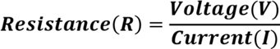

Whereby; V is voltage in volts I is current in Amps (A)

R is resistance in Ohms (Ω)

Ohms law
It states that current passing through a conductor is directly proportional to its voltage provided temperature remains constant. Mathematically:
𝑉=𝐼𝑅

Example
An electric appliance is connected to a 240v power supply. Work out its resistance if it allows a current of 30A to flow through it.

Solution
R=V/I
R= 240V/30A
R= 8Ω

Plotting graphs of voltage against current

Resistance of a material can be found
by calculating the slope of the voltage (y-axis) against current (x-axis) on the graph.
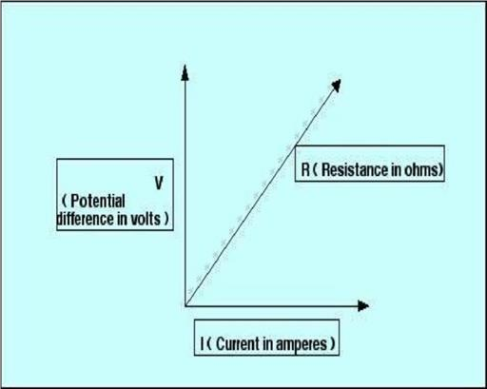

Activity

A student conducted an experiment to find out the relationship between current flowing through nichrome wire and voltage across it. The results of the experiment are summarized in the table below:

Current (A) | 0 | 0.2 | 0.4 | 0.6 | 0.8 | 0.9
Voltage (V) | 0 | 1 | 2 | 3 | 4 | 5

- Draw the graph of voltage against current.
- Use the graph to calculate the resistance of the wire.
Factors affecting theresistance of a wire

  - Length of the wire.
As the length of wire decreases there are few collisions that take place between flowing electrons and stationary positive ions. In other words, there is reduction

in opposition to the flow of electrons because there are fewstationary positive ions that can cause resistance.
In general; short wire provides low resistance and longer wire provides higher resistance

  - Thickness of the wire.
Electrons are able to flow freely in thicker wires, hence low resistance. In thinner wires, electrons straggle to move freely, hence higher resistance. In other words, resistance of the wire varies inversely with its cross sectional area or thickness. In general, resistance of the wire decreases as the thickness increases.

  - Temperature.
Increase in temperature of the wire increases the kinetic energy of the stationary positive ions in the wire. These particles increase their vibrations and cause more collisions with the flowing electrons hence leading to increase in resistance. In general, low temperature results in low resistance and high temperature results in high resistance

  - Nature of the material of the wire. Copper wire gives high current because it has low resistance. Nichrome wire gives low current because it has high resistance. In general, different wires are made up of different materials that have different resistance.
CHAPTER 13: EFFECTS OF ELECTRIC CURRENT

- Electricity is the most widely used form of energy.

- It is used for cooking, lighting or heating. In form of electrical energy, electric current has a lot of effects.
- The main effects of electric current are
    - heating effect
    - magnetic effect
    - chemical effect

HEATING EFFECT
Current has the heating effect. When current flows through a resistive material, heat energy is produced.
Therefore, electrical energy provided by the cell or battery is changed to heat energy.

Application of heating effect of electric current
Heating effect of current is used by the following appliances.

- Electric filament lamp.
An electric filament lamp uses tungstenwire of high resistance in order to give light.
- Heating element. A heating element is made of nichrome wire which has high resistance. When current flows througha heater, heat is produced due to very high resistance. Heating elements are used in electric iron, electric kettles and immersion heaters.
- Bimetallic strip

It is made up of two metals placed side by side. Remember that different metals expand differently. Example of bimetallic strip is a strip made of copper and iron metal.

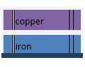
When the bimetallic strip is heated copper gets longer than iron because it expands more than iron. Hence the bimetallic strip bends with copper forming the outside part.

Uses of bimetallic strip
- It is used as a switch. And it is known as thermostat when used in a circuit.
- A thermostat is used as a temperature control in an electric iron, fridges and many more appliances.

- Fuses

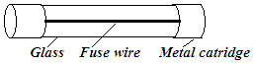
- A fuse is a safety device made of thin- lead alloy. The resistance of a thin- lead alloy is higher than that of copper wire; hence it becomes hot when current flows through it.
- It is used to control the amount of current flowing through an appliance or cable. This prevents cables and appliances from carryinghigh current which can cause overheating and fire.
- When the amount of current flowing in a fuse is more than the required amount of current, a fuse melts. The melting of the fuse breaks the circuit
and prevents the flow of high current in the circuit.

MAGNETIC EFFECT OF CURRENT

When current flows through a wire, it produces magnetic field in the wire.
The directions of current and magnetic field are found by using
- the right hand rule

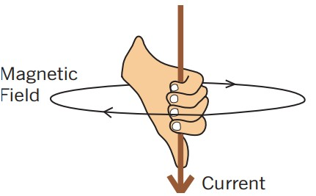

Using right hand rule,
- One holds the conductor with a right hand and with all the fingers including the thumb.
- The thumb points to the direction of the current.
- The fingers point to the direction of the magnetic field.

- Compass needle pointers

- The direction of the magnetic field is found by placing compass needle pointers around a conductor.
- Where there is no current flowing in a conductor, the compass needle pointers are not deflected.
- When the current is flowing in a conductor, all the compass needle pointers are deflected as shown in

figures below.

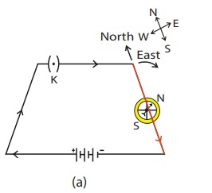
If the current flows from north to south, as shown in Fig (a), the north pole of the compass needle would move towards the east
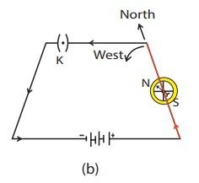
If the current flows from south to north, as shown in Fig (b), the north pole of the compass needle would move towards west

Ways of increasing the strength of magnetic field produced in a wire
- By increasing the number of cells which will cause an increase in theamount of current.
- Coiling the wire. A long coiled wire is called a solenoid.
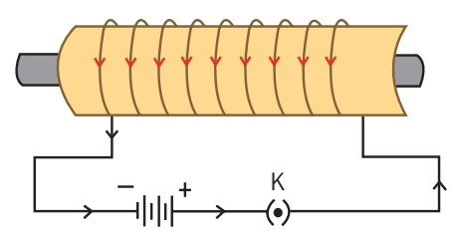

Ways of increasing the magnetic field produced in a solenoid
- By increasing the amount of current flowing through the solenoid by increasing number of cells.
- Placing an iron core in a solenoid. A combination of an iron core (iron nail) and solenoid makes an electromagnet.

ELECTROMAGNET

- Electromagnet is a long coil of wire with an electric current.
- An electromagnet is a combination of a solenoid and an iron core. Iron is used instead of steel because iron forms a temporary magnet while steel forms a permanent magnet.

Factors affecting the strength of theelectromagnet
The strength of an electromagnet can be increased by:

- Increasing the amount of currentflowing through the coil.
- Increasing the number of turns of thecoil.
- Inserting a soft iron core along
theaxis of the coil.

Application of electromagnets in everydaylife
  - The electric bell
- It contains an electromagnet that switches itself on and off very rapidly.
- This moves the bell hammer which strikes the gong.

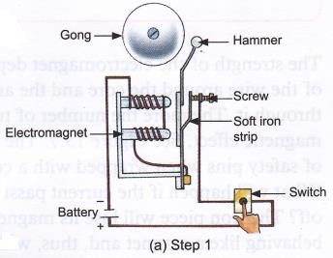
- Step 1: When you push the switch of the bell, an electric current flows to the electromagnet
- Step 2: The electromagnet attracts the soft iron strip. The hammer attached to the strip then hits the gong, making it ring
- Step 3: When the soft iron strip gets attracted to the electromagnet, it no longer touches the screw (interrupter) and hence the circuit is broken. This turns off the electromagnet and it can no longer attract the soft iron strip. The soft iron strip returns to its initial position, touching the screw (interrupter). This results in the circuit being complete, and current flows again

  - Magnetic relay
    - It is a switch which uses an electromagnet
    - A magnetic relay uses the principle of induction to control electronic circuits and devices.
    - A coil of wire sets up a magnet field that is concentrated around a core.
    - This magnetic field is used to physically open and close circuits or
activate armatures for mechanical work.
    - One of the key advantages of electromagnetic relays isthat they are electrically and physically separate from the circuits they control.
    - Another distinct advantage of relays is their ability to switch circuits.
    - This ability eventually has given rise to more powerful and faster electronics, including the modern computer and microprocessor.
    - One is shown below.

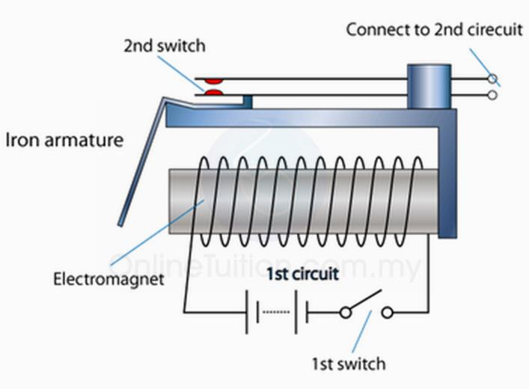
  - Simple electric motor
- A motor is adevice that converts electric energy to mechanical energy (motion)
- It is based on the fact that when a current carrying conductor is placed in a magnetic field, it experiences a force and so it moves.
- This force can be usedto drive electric machines. A simple electric motor consists of a rectangularcoil of wire between poles of a strong magnet.
- The two ends of the coil are soldered to a commutator (two halves of a split ring). Two brushes press lightly

against the commutator. When the circuit is connected to a source of current the coil rotates.
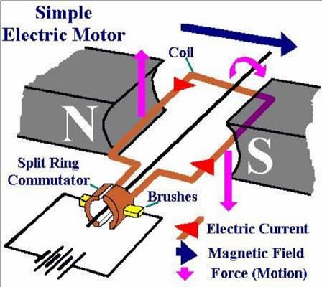

CHEMICAL EFFECT

- When current passes through the liquid, itbreaks the liquid into ions. The passing of current through the liquid and breaking down the liquid is called electrolysis.
- The substance that can conduct current in aqueous or liquid form is called electrolyte.
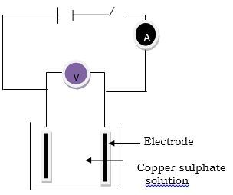

- In the figure, above when you just close the switch, the gas bubbles on the electrode will be seen.
- When you remove the carbon rod from the solution you observe change in colour of the surface of the carbon rod. Brownish coat is formed on the surface.
- This shows that there are chemical reactions taking place in the solution ofcopper sulphate.
- Therefore, current has a chemical effect.

Applications of chemical effect of current

- In electroplating
- This is a process where one metal is coated with a layer of another metal once dipped in an electrolyte and electric current passes through. It is done to improve appearance and quality of a material.

- In purification of metals
- An impure metal is purified by letting the impurities also known as sludge fall from it in electrolysis process.
- Chemical cells
- These are made up two different metals called electrodes and conducting liquid called electrolyte. Cells store chemical energy and are transducers. Cells convert chemical energy to electrical energy.

Wet and dry cells

- Cells are the sources of electricity in powering radios, watches and torches.
- The electricity is produced from chemical energy which is released from the cells by a chemical reaction.

- The type of electricity which is produced is in the form of direct current.

  - Wet cell
A wet cell has a liquid electrolyte. The liquid covers all the internal parts.
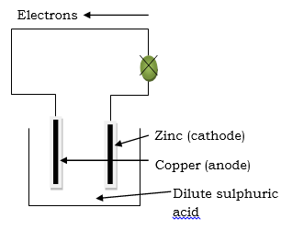
- Zinc rod acts as the negative electrode, copper rod acts as the positive electrode and sulphuric acid acts as the electrolyte.
•
- The zinc rod slowly dissolves in the acid, and loses electrons. These electrons flow in the external wire through the component (i.e. bulb) to the carbon plate. Hydrogen ions in the sulphuric acid go to the copper rod andgain electrons coming from zinc rod to become hydrogen gas.
- Wet cells are further classified into two and these are primary cells and secondary cells

- Primary cell.
In primary cells chemical energy is directly changed into electrical energy. It is mainly made of zinc and copper electrodes dipped in sulphuric acid. Has zinc and copper plates as electrodes and
dilute sulphuric acid as the electrolyte.

- Secondary cell.
In secondary cell, the cell must be charged first before it can convert chemical energy to electrical energy. When not in use, the cell reconverts electrical energy to chemical energy and will not to be recharged to be used again and this process is reversible unlike in primary cells.

Disadvantages of wet cell
- The disadvantage of this cell is polarization (the formation of bubbles of hydrogen on the copper rod)
- It produces low voltage of about 1V. Therefore, it cannot be used for practical purposes.

  - Dry cell
- A dry cell contains a zinc container containing paste which contains ammonium chloride with a carbon rod at the center. This makes it more portable than the wet cell.
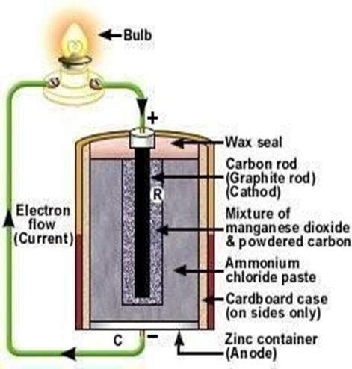
- The structure of a dry cell is shown below.

Ways of caring for wet cells

Cells can be stored at low temperature.This slows the side reaction.

Maintenance of wet cells

Wet cells can be maintained as follows:

- Water is added to make up forloss by evaporation.
- The dissolving zinc negative electrode should be replaced regularly.

Disposing of dry and wet cells
Cells can be disposed by the following methods.

  - Incinerate (burn completely) the cellwhile it is wrapped in a plastic bag.
  - Recycling
Cells are in the form of electronic waste (e-waste). Therefore, e-waste recycling services recover toxic substance which can then be used for new cells.

Impact of poor disposal of wet and dry cells

- Cause environmental damage: mostcells contain toxic materials which damage the environment.
- Small button cells can be fatal ifswallowed, mainly by kids.
CHAPTER 14: MAGNETS
- A magnet is a piece of metal with either natural or induced properties of attracting another metal objects
- Magnetism is the force exerted by magnets when attract or repel each other
Magnetic and non-magnetic materials
- Materials may be classified according to their magnetic properties. There are those that are attracted by magnets and others that are not.

- Magnetic materials:
- The materials which are attracted by a magnet are called magnetic materials.
- The magnetic materials that are strongly attracted by a magnet are called ferromagnetic materials. These include nickel, iron, cobalt and steel

- Non-magnetic materials
- Materials that are not attracted by a magnet are called non-magnetic materials. Examples of non-magnetic materials include copper, brass, aluminum, wood, cork, plastic and all non-metals. They are also called non- ferrous metals.

Magnetic poles
- The ends of a magnet where the attraction is strongest are known as the magnetic poles.
- Magnetic poles are the places in a magnet where the total attractive force seems to be concentrated.
- The pole that points towards the north pole of the earth is called the north seeking pole or simply the north pole (N). The other pole is called the south

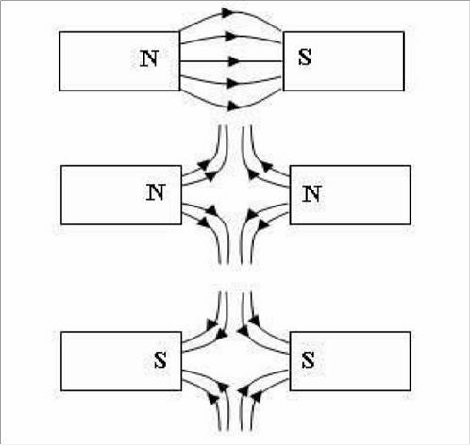
seeking pole or south pole (S).


Magnetic force
- It is a force of attraction and repulsion provided by a magnet.
- Magnetic force of a magnet has the following characteristics:

- It is either attractive or repulsive.
- Attracts only magnetic materials.
- It is greater at the poles.
- It acts in all directions.
- Increases when the separation distance decreases.

Magnetic field
- Magnetic field is the area around the magnet where the effect of magnetism is felt
- Magnetic field is represented by lines of force called magnetic lines.
- These magnetic lines form a pattern called magnetic field pattern

  - These lines of force are always drawn from North Pole to South Pole. When N and S poles of different magnets are brought close, lines are drawn from N to S
  - When N and N (two N) poles of different magnets are brought close, lines are drawn away from each N
  - When S and S (two N) poles of different magnets are brought close, lines are drawn toward each S
This is shown in the diagram below.

Magnetic field is strongest where the field lines are closest (at the poles). This means that magnetic forces are strongest at the poles.

Types of magnets
- Permanent magnets: those magnets that retain magnetic properties for a long time. They are made from hard magnetic materials e.g steel. They occur naturally
- Temporary magnets are those magnets which act as magnets only when there is a flow of electric current or a presence of a permanent magnet. They lose magnetism when the permanent magnet is removed or electric current is cut off. An example of temporary magnet is an electromagnet.

Basic law of magnetism (firstlaw of magnetism)

- When the North pole is brought closer to the South Pole of another bar magnet, there will be attraction.
- Therefore, unlike poles attract.

- When the North Pole of one bar magnet is brought closer to a North Pole of another magnet, there will be repulsion. Therefore, like poles repel.
- Therefore, the first law of magnetism states that: unlike poles attract each other while like poles repel each other.
- The law is shown in the diagrams below
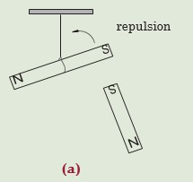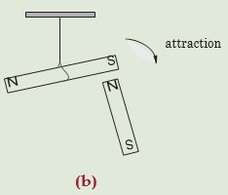

Identifying the polarity of unmarked magnet using law of magnets

Polarity is when an entity contains two distinct and opposite poles that can either attract or repel each other

Experiment

Test for polarity of a magnet using the basic law of magnets

Apparatus: Nail, two bar magnets, cotton
thread

Procedure
- Freely suspend a bar magnet as shown in figure below.
- Bring one pole magnet close to a nail placed on the table

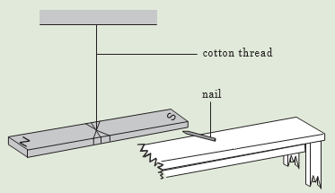
- Repeat with other pole close to the nail. Record your observations.
- Repeat these procedures using a second bar magnet instead of a nail.

Observation

- There is attraction when the south or north pole of a suspended magnet is brought near the nail.
- When the second bar magnet is used, there is attraction with one pole and repulsion with the other pole.

There is always an attraction between a magnet and a magnetic material and also between the unlike poles of magnets. But there is only repulsion between two like poles of the magnets.

Therefore, repulsion is the only sure way of testing for polarity of a magnet.

Uses of magnets

They are used in:
- Hospitals for removing iron pieces from the eyes of the patients.
- Industries as stirrers, lifting ironscrap metals, etc.
- Weather stations for resetting Six’s maximum and minimum thermometer.
- Navigation for showing the directionas in compass needles.
- Magnetic tapes used in audio and video recorders.

Storing magnets

- Since a bar magnet tends to become weaker with age, it is advised that magnets should be stored in pairs with opposite poles adjacent and with small pieces of iron called keepers placed across their ends.

Exercise
  - Explain the meaning of the following terms:
    - a magnet.
    - a magnetic substance
    - polarity
  - Group the following materials into magnetic and non-magnetic materials: Zinc, paper, aluminium, graphite, steel and plastic.
  - Explain how you can identify the polarity of a magnet whose poles are not marked?
  - Differentiate temporary from permanent magnets
  - The magnets shown in Figure below, pole B attracts pole P and pole Q attracts pole X.



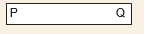
If pole Y is South pole,
    - What is the polarity of P?
    - What would happen if the following poles are brought close together:
      - pole B and X
      - pole A and pole Q
      - pole B and pole Y
    - Draw a magnetic field pattern when pole B and P are placed near each other.

