MSP Marketing Edge
Advertising pack: May 2018

Google AdWords

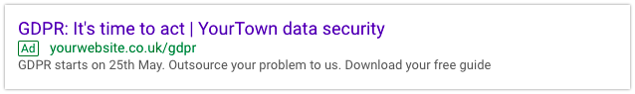

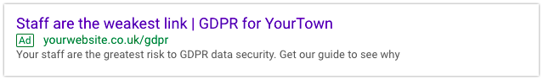

Facebook

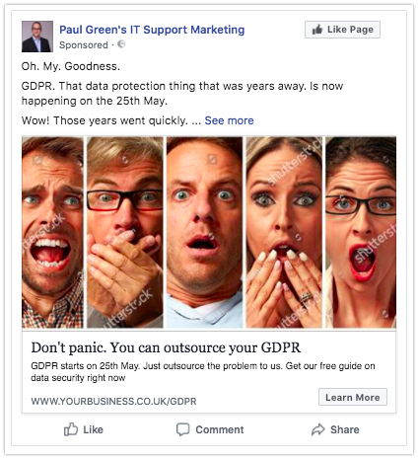

Facebook image search: Panic

Oh. My. Goodness.

GDPR. That data protection thing that was years away. Is now happening on the 25th May.

Wow! Those years went quickly.

Now it's time to act. In fact, there's a great deal of urgency to it.

Because you know how your business is most at risk? From poor data security.

You lose a laptop somewhere, and you're in big trouble. Under GDPR, any time personal data is compromised, you have to tell the regulator AND the people whose data you lost.

Groan. New headache.

Of course, there's a simple answer. Just outsource the problem to us. We're experts in data security. And will just make the issues go away for you.

Let's start a relationship. The first step is for you to download our free guide to GDPR (written so anyone can understand it).

Click the link now for an immediate download.

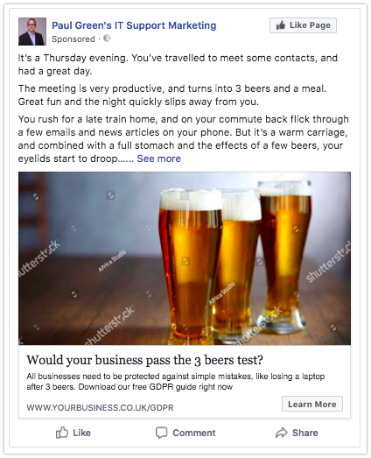

Facebook image search: 3 beers

It’s a Thursday evening. You’ve travelled to meet some contacts, and had a great day.

The meeting is very productive, and turns into 3 beers and a meal. Great fun and the night quickly slips away from you.

You rush for a late train home, and on your commute back flick through a few emails and news articles on your phone. But it’s a warm carriage, and combined with a full stomach and the effects of a few beers, your eyelids start to droop…

(we’ve all experienced something like this, haven’t we?)

You wake with a start as the train pulls to a stop, and you hear the automated voice announce the train has arrived at… your stop. In a rush you grab your phone, coat and jump off the train onto the platform.

Yes! You did it! That was close…

The train starts to pull away… and suddenly you feel sick.

Your laptop bag. Where’s your laptop bag? You put it in the luggage rack… Oh… My… IT’S STILL ON THE TRAIN…

You watch with despair as the train pulls away, taking your laptop with it.

A few years ago, a situation like this would have just been annoying and inconvenient. But that’s about it. Laptops are easily replaced commodity products. Data backups mean your information can be recovered.

However, under GDPR, this scenario has potentially quite a different outcome.

Because the new law requires you decide whether or not a data breach – which includes losing data – should be reported to the authorities… and to the people whose data has been lost.

Sound like something that could happen to your business? Get our free GDPR data security guide today. Click the link to download it straight away.

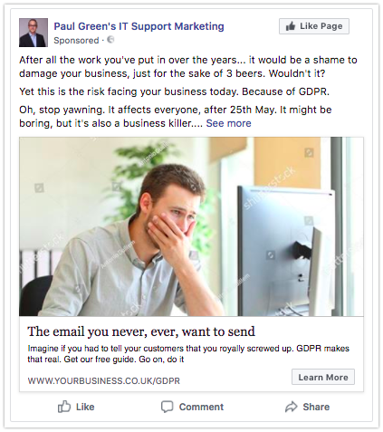

Facebook image search: Bad email

After all the work you've put in over the years... it would be a shame to damage your business, just for the sake of 3 beers. Wouldn't it?

Yet this is the risk facing your business today. Because of GDPR.

Oh, stop yawning. It affects everyone, after 25th May. It might be boring, but it's also a business killer.

We've developed something called the 3 beers test, to check your business's readiness for GDPR.

The 3 beers test is very simple. Imagine you were the boss of a business, and you popped into London for a few meetings. You have 3 beers with a friend, and on the train home you fall asleep.

You wake just as the train is pulling into your station – and in your utter panic to get off, disaster strikes! You leave your laptop on the train and it’s lost.

Under GDPR, this would be a major problem.

If there’s any personal data on your laptop at all, you’re in serious trouble. You must tell the regulator you’ve lost data, but worse, you must also tell the people whose data has been compromised.

Read that again - you must also tell the people whose data has been compromised.

Argh! Clients. Suppliers. Key partners. The email you never, ever, want to send. Or the phone call that will hurt so much if you have to make it.

Your business can be fined. And you can be publically named and shamed. I believe the reputational damage is the greatest risk, because it will sit there forever in Google.

Fortunately, there are a number of clever technological fixes that would allow any business to easily pass the 3 beers test, such as data encryption. This protects data even if a laptop is lost or stolen.

Learn more by downloading our free guide to GDPR data security, right now.

LinkedIn

